**Allergy & Asthma**

**Center of Texas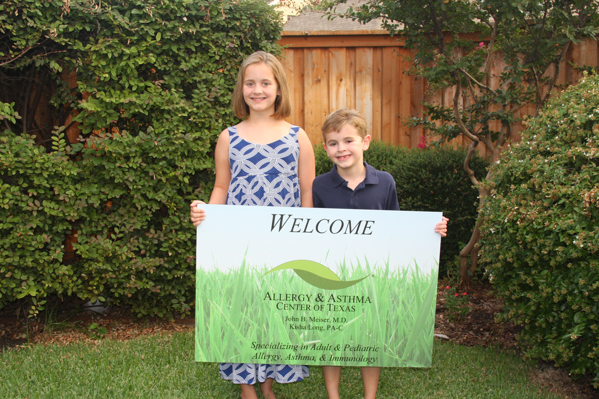of texas**

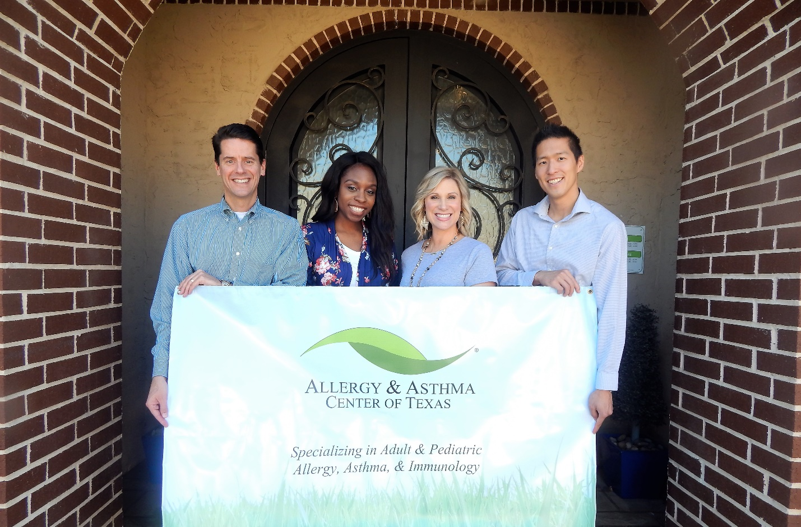

***Specializing in Adult & Pediatric***

***Allergy, Asthma & Immunology***

***We treat:***

Allergic Rhinitis • Conjunctivitis • Asthma • Food Allergies

Drug Allergies • Eczema • Recurrent Infections

6946 Lebanon Road

Frisco, Texas 75034

(NW corner of Lebanon Rd and North Dallas Tollway)

(972) 377-9987 Phone (972) 377-9906 Fax

www.AACTMD.com